Case 3-ME-Iraq-Gilgamesh-Palace of Sargon II at Khorsabad

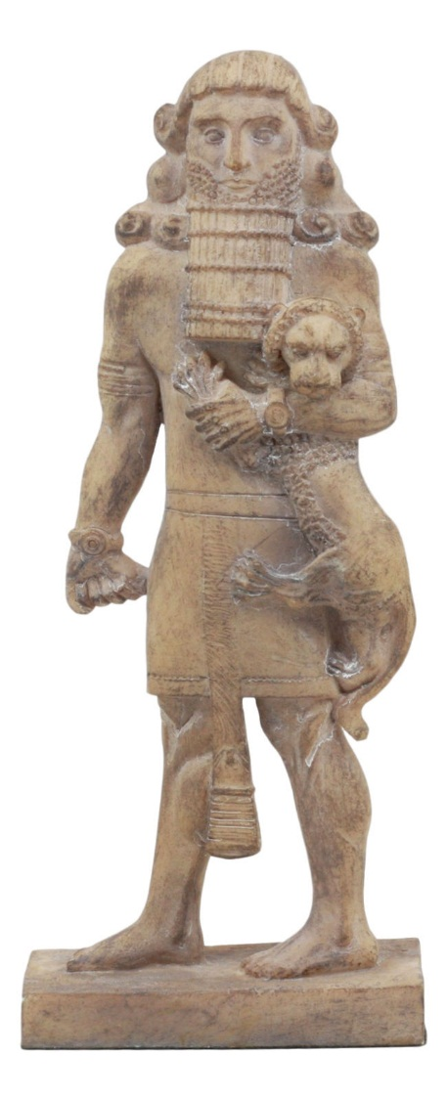

This colossal figure choking a lion once stood at the palace of Assyrian king Sargon II at Khorsabad in northern Iraq. Often identified with the hero Gilgamesh, the statue now resides at the Louvre Museum in Paris. Musée du Louvre, Paris. Gilgamesh subduing a lion, [Louvre](https://en.wikipedia.org/wiki/Louvre) museum

Tzvi Abusch, [**“Gilgamesh: Hero, king, god and striving man,”**](http://members.bib-arch.org/publication.asp?PubID=BSAO&Volume=3&Issue=4&ArticleID=10) Archaeology Odyssey, July/August 2000.

Karel van der Toorn, [**“Did Ecclesiastes Copy Gilgamesh?”**](http://members.bib-arch.org/publication.asp?PubID=BSBR&Volume=16&Issue=1&ArticleID=9) Bible Review, February 2000.

Jack Meinhardt, [**“Gilgamesh—Like You’ve Never Seen Him Before,”**](http://members.bib-arch.org/publication.asp?PubID=BSAO&Volume=8&Issue=4&ArticleID=3) Archaeology Odyssey, July/August 2005.

